**[The Museum of Us](http://nceonline.zju.edu.cn/new/books/book4/cached_general/u7_in_class_reading.htm" \l "null)**

1. In my mother's house, ***tucked away*** in a drawer, there is an aviator cap. It is a little fragile now. The first time my grandfather wore it, he was 17. And it was 1933. In a small town in Northern Italy, Mario Messina had ***fulfilled a dream***. He became the youngest aircraft pilot in Italy. Ahead of this young man lay ***a long life lived across two continents***, a world war, a family and countless hours of flying. But in ***the photograph that sits on my desk*** is a proud aviator, standing tall beside his plane.

fulfil

|  |  |
| --- | --- |
| to do or achieve what was hoped for or expected 实现 | to fulfil your dream/ambition/potential  实现梦想 / 抱负；发挥潜力 |
| to do or have what is required or necessary 履行；执行；符合；具备 | to fulfil a duty/an obligation/a promise  履行职责 / 义务 / 诺言  to fulfil the terms/conditions of an agreement  执行协定条款 / 条件  No candidate fulfils all the criteria for this position.完全符合这个职位的标准 |
| to have a particular role or purpose 起…作用；目的是 | Nursery schools should fulfil the function of preparing children for school.  幼儿园应该起到为儿童进小学作准备的作用。 |
| ~ sb/yourself to make sb feel happy and satisfied with what they are doing or have done 使高兴；使满意 | I need a job that really fulfils me.  我需要一份真正令我感到满足的工作。  He was able to fulfil himself through his painting.  他通过绘画充分发挥了自己的才能。 |

[ ] President Kaunda fulfilled his promise of announcing a date for the referendum (全民公决).

[ ] All the necessary conditions were fulfilled.

[ ] The war was the biggest thing in her life and nothing after that quite fulfilled her...

[ ] They don't like the idea that women can fulfil themselves without the assistance of a man.

fulfilment (British English) (North Amercian English fulfillment) 　[不可数名词]

the fulfilment of a dream 梦想的实现

to find personal fulfilment 寻求个人的满足

hierarchy of needs: (How do you explain it？)

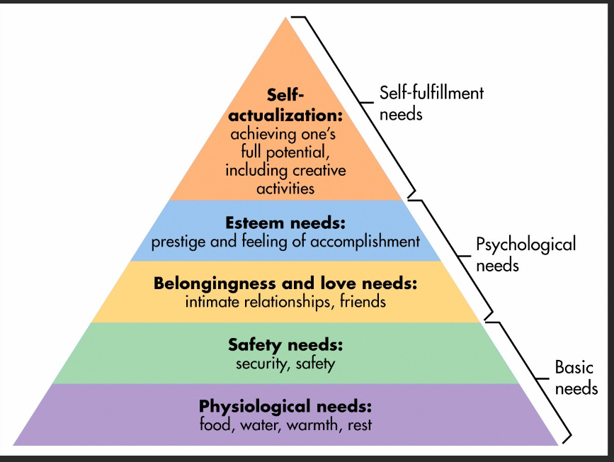

. Ahead of this young man lay ***a long life lived across two continents***,

同源宾语：  
dream a dream 做梦

live a life 过生活

She only slept a wink last night.

sing a song

die a death

We slept a comfortable sleep last night.

You should run your fastest（race）.

The old man breathed his last（breath）this morning.

<https://baijiahao.baidu.com/s?id=1720272556587680011&wfr=spider&for=pc>

1. If I offered Mario's cap to a museum today, they might reject it because it lacks significance to the general public and therefore it is not considered a museum piece. After all, many of those caps were made and many are probably ***still in existence***. No one famous wore the cap. ***Nothing distinctively unusual*** happened to the cap or the person wearing it. The life of the cap was ***mundane*** and private.

|  |  |
| --- | --- |
| [不可数名词, 单数] ~ (of sth) the state of not having sth or not having enough of sth 缺乏；匮乏；短缺 (= shortage) | a lack of food/money/skills  The trip was cancelled through lack of (= because there was not enough) interest. |
| no lack of | There was no lack of volunteers.  He said there was no lack of things for them to talk about.  President Clinton displayed no lack of vigor when he began to speak. 颇有气势 |
| [动词 + 名词短语][无被动态] to have none or not enough of sth 没有；缺乏；不足；短缺 | Some houses still lack basic amenities （基本设施） such as bathrooms.  He lacks confidence.  She has the determination that her brother lacks. |

lacking

|  |  |
| --- | --- |
| [名词前不可用]  ~ (in sth) having none or not enough of sth 没有；匮乏；缺乏；不足 | She's not usually lacking in confidence.  The book is completely lacking in originality.  He was taken on as a teacher but was found lacking (= was thought not to be good enough) . 能力却显得一般。 |
| not present or not available 不在场；得不到 (= missing) | I feel there is something lacking in my life.  我觉得我的生活中缺少点什么。 |

造句：

mundane: (often disapproving) not interesting or exciting 单调的；平凡的 （dull, ordinary）

a mundane task/job 平凡的任务 / 职业

I lead a pretty mundane existence. 我过着相当平淡的生活。

On a more mundane level, can we talk about the timetable for next week? 说点儿实际的吧

the mundane realities of life

Be willing to do even mundane tasks.

造句：

[3] And yet it is no ordinary aviator cap. It is unlike the caps we wear every day to ***keep the harsh Australian sun out of our eyes*** — caps that are fashionable but meaningless, caps that are **easily bought, easily lost and easily replaced**. **So what occupies that place between *a museum piece* and *an everyday functional object*?** And how?

[4] There are ***accessories*** and ***apparel*** that live in that place in ***the everyday, unremarked lives of many families.*** Many families ***house an invisible, private museum*** ***populated with items s***uch as my grandfather's aviator cap, which are ***not worthy of inclusion in public museums*** and yet are d***istinctly different from*** the other objects which fill people's houses. They are not ***catalogued or curated*** yet they are taken care of and ***their history is passed down through generations***. They may not carry (inter)national historical significance but nor are they ***devoid of meaning***.

worthy

|  |  |
| --- | --- |
| ~ (of sb/sth) (formal) having the qualities that deserve sb/sth 值得（或应得）…的 (反义：unworthy) | to be worthy of attention  A number of the report's findings are worthy of note .值得注意  No composer was considered worthy of the name until he had written an opera. 被认为是名副其实  a worthy champion (= one who deserved to win) 当之无愧的冠军  He felt he was not worthy of her. 他觉得他配不上她。 |
| [常用于名词前] having qualities that deserve your respect, attention or admiration 值得尊敬的；值得注意的；值得敬仰的 （= deserving） | The money we raise will be going to a very worthy cause .  a worthy member of the team●  They thought the feminist label was too worthy.  他们觉得女权主义者这个称谓太抬举她们了。 |

Translation:

|  |  |
| --- | --- |
| 银行也许会认为你具备贷款的条件。 | The bank might think you're worthy of a loan... |
| 部长说这个想法值得考虑。 | The Minister says the idea is worthy of consideration... |
| 团体中德高望重者 | worthy members of the community |
| 一位优秀的队员 | a worthy member of the team |
| 当之无愧的冠军 | a worthy champion |
| 他觉得他配不上她 | He felt he was not worthy of her. |

worthwhile: ~ (to do sth) | ~ (doing sth)

important, enjoyable, interesting, etc.; worth spending time, money or effort on 重要的；令人愉快的；有趣的；值得花时间（或花钱、努力等）

It was in aid of a worthwhile cause (= a charity, etc.) . 这是在为高尚的事业尽一份力。

The smile on her face made it all worthwhile.

High prices in the UK make it worthwhile for buyers to look abroad.

It is worthwhile to include really high-quality illustrations.

It didn't seem worthwhile writing it all out again.

The President's trip to Washington this week seems to have been worthwhile.

a worthwhile movie that was compelling enough to watch again... 非常吸引人的影片

house

|  |  |
| --- | --- |
| 1. to provide a place for sb to live 给（某人）提供住处 | The government is committed to housing the refugees.  政府承诺收容难民。 |
| 1. to be the place where sth is kept or where sth operates from 是（某物）的贮藏处（或安置处）；收藏；安置;作为…之用 | The gallery houses 2 000 works of modern art.  美术馆收藏了2 000件现代艺术作品。  The museum is housed in the Old Court House.  博物馆设在旧法院大楼里。  ● The château itself is open to the public and houses a museum of motorcycles and cars...  设有一个摩托车和汽车博物馆 |

[ ] Part III of the Housing Act 1985 imposes duties on local authorities to house homeless people...

[ ] Regrettably we have to house families in these inadequate flats. 狭小的公寓

[ ] The building will house twelve boys and eight girls...

[ ] Their villas housed army officers now. 他们的别墅里现在住着军官。

[ ] Part III of the Housing Act 1985 imposes duties on local authorities to house homeless people.

[ ] Regrettably we have to house families in these inadequate flats.

很遗憾，我们不得不让住户挤在这些狭小的公寓里。

[ ] Many years later, the temple erected in her name was used to house the Roman mint (铸币厂).

1. ***Alongside* public institutions and private collections** stands a third type of museum ***invisibly （P130练习）***— the Museum of Us. It is filled with objects that the family ***deems precious*** because of ***an affective association*** between an object and a particular member of that family. These objects are ***inscribed with affective wealth and powe***r. They have the power to create connections between family members and between generations. They have the power of creating ***a feeling of belonging***, as they allow family members to know their family history ***through more detailed and tangible narratives***. I always knew my grandfather was a pilot; he took me flying with him when I was three. And yet, holding his cap, the cap that sat on the head of the grandfather I loved, creates something more than just the memory or the knowledge of Mario, the pilot. I touch it; I try it on. The love that I feel for my grandfather ***coalesces in the fibres and stitches of the aviator cap***. It makes me ***rich in connectedness.*** It makes me feel powerful from the security that ***positive family links*** can bring.

alongside

|  |  |
| --- | --- |
| Prep: next to or at the side of sth 在…旁边；沿着…的边 | A police car pulled up alongside us. |
| Prep: together with or at the same time as sth/sb 与…一起；与…同时 | Traditional beliefs still flourish alongside a modern urban lifestyle.  现代城市生活方式盛行的同时，传统信念仍然大行其道 |
| adv. | Nick caught up with me and rode alongside. |

[ ] He crossed the street and walked alongside Central Park.

[ ] Much of the industry was located alongside rivers.

[ ] He had worked alongside Frank and Mark and they had become friends...

[ ] Men aged 60 are fighting alongside young boys.

[ ] Her self-confidence will develop alongside her technique.

造句：

[6] How did my grandfather's cap ***survive*** long enough to b***e inscribed with enough meaning*** so that it could become ***priceless*** to us? Did Mario know, at the time of wearing it, that this would not be just another ordinary cap? That it was a precious item that belonged in the Museum of Us? I dare say not. These precious objects ***start out as ordinary objects***. It is only through time, re-visitation and ***conservation*** that they become meaningful. I think of so many scarves, caps, dresses, handbags, ties and shirts that never had the opportunity to enter the Museum of Us simply because they were ***discarded*** or lost too early to have acquired meaning.

[7] In order to get these pieces ***accessioned*** into the Museum of Us, ***it is incumbent on family members to become their guardians.*** In my family at least, there is never a meeting or a conversation about which item belongs in the Museum of Us and who is to be its ***guardian*** for each generation. There is only the odd Sunday afternoon conversation about the cap, or a story about Mario's wartime adventures, or ***a flick through an old family photo album***. Weeks and months and years can go by without family members viewing or discussing the piece. The ***meaning-making*** and hence the importance of it grows slowly and ***organically***, ***through casual re-visitations*** by different members of the family. Through it, I can more easily maintain my connection to a man who was a wonderful grandfather, even though he passed away in the early 1990s.

|  |  |  |
| --- | --- | --- |
| 英国三大报纸？ | 《卫报》《泰晤士报》《每日电讯报》 | *The Guardian, Times, The Daily Telegraph* |

8 Besides the cap, there are more items in the Museum of Us. They are ***scattered through the wardrobes and chests of my family members.*** They have no ***display cabinet;*** they have had no ***opening night festivities.*** But maybe they should. Because these items are unique, not in the same way that there has ever only been one Mona Lisa but in the ***uniqueness*** they have acquired from the stories written along each thread and stitch. These are the narratives that help ***sew families together***. Perhaps the next ***iteration*** for my family is to come together and ***purposefully accession, curate, catalogue and display the precious, unique objects*** in the Museum of Us. And invite the rest of the family to an opening night party.